ENROLLMENT NUMBER: IU2341231551 SUBJECT: ICT(CE0325) BATCH: 3CSE-E

PRACTICAL - 1

Aim: Create Google form For Student Registration to attend a Janmashtami Festival. (With File Upload).

Solution: Janmashtami Celebration

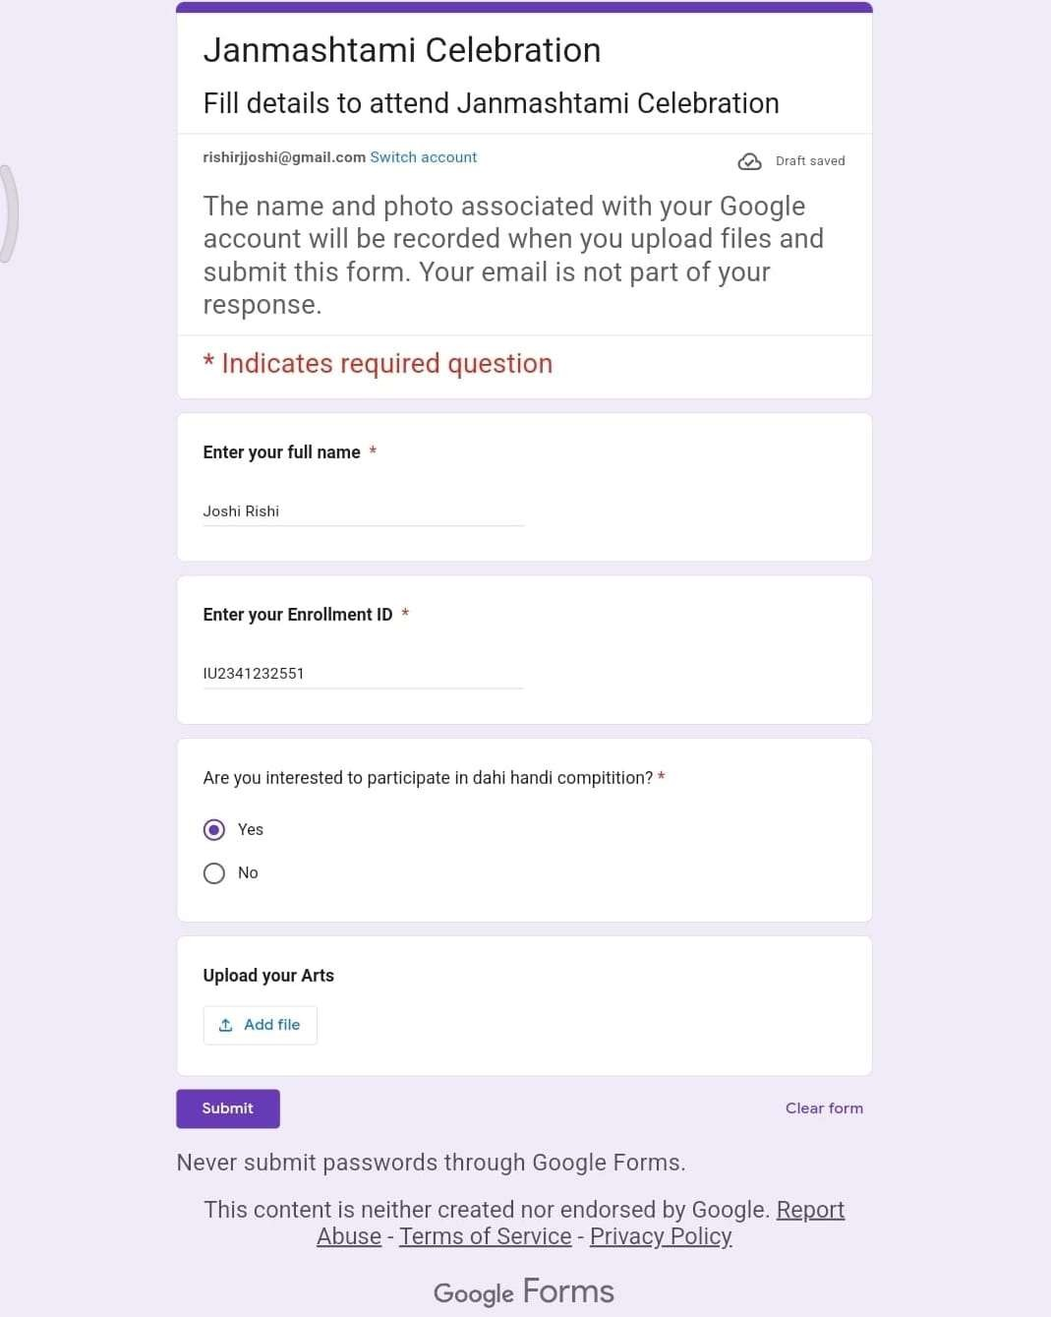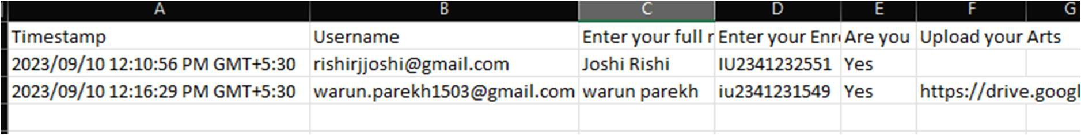

Signature of Faculty: Date:

Page **1**